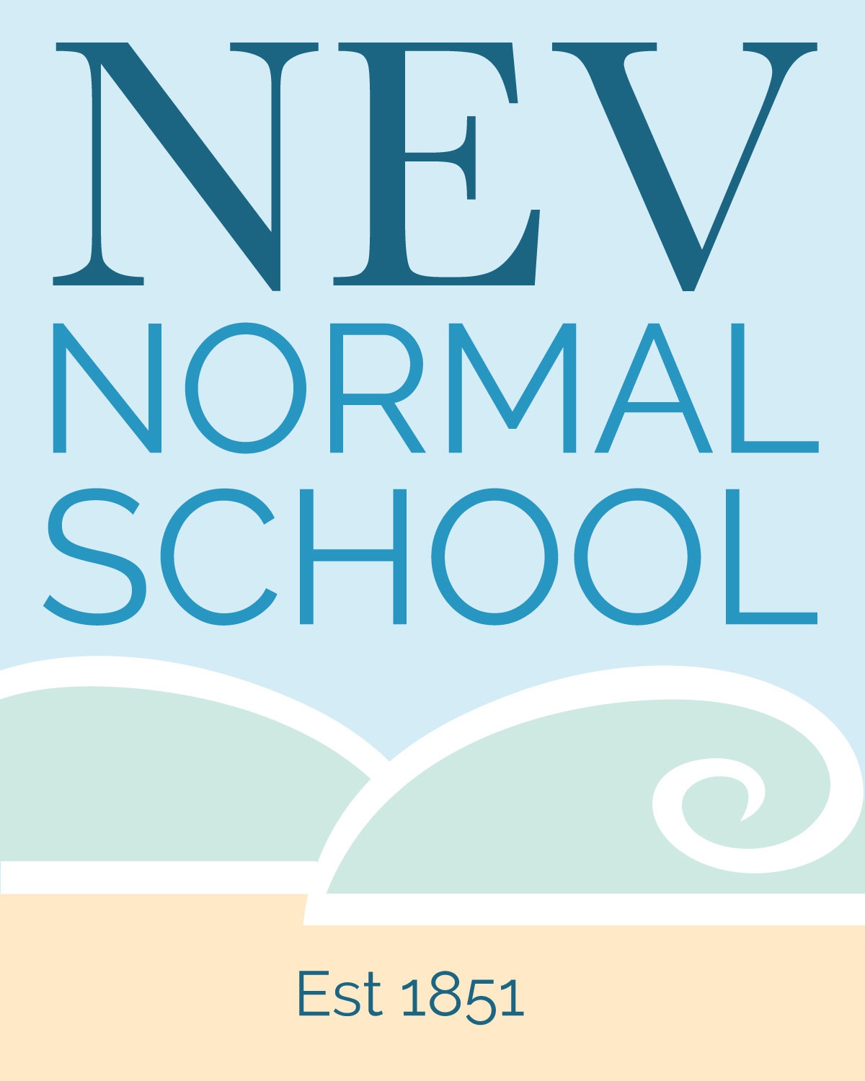

School Newsletter Week 8 Term One 2021 - 23rd March

Kia ora e te whanau.

**Sara Blackwell**, our long-serving and long-suffering office manager/school secretary/first aider/payroll officer etc etc is on leave for the rest of the school term. Sara underwent major surgery last week and is currently recuperating at home. Sara reports the surgery went well. We wish Sara all the best and look forward to her return to good health and to school. Needless to say, we are struggling to do all the many things Sara normally does but thus far we are coping! Jessica - Connor and Jackson’s mum - is doing the clerical work in the meantime so please bear with her and us as we do our best in this area.

**Thoughts from a recent seminar**:

The Otepoti ki te Raki community of learning recently hosted a speaker whose theme was reducing stress. His seminars were well received by local principals and teachers. During his session with parents he talked about balancing **correction** with **connection** when dealing with children at home. I thought this was a simple lesson for parents - too much correction can lead to resentment; try to make strong connections so that when you do correct it isn’t a dominant factor in your relationship with your tamariki.

**Cross Country next Tuesday:**

Cross Country is taking place at school on Tuesday 30 March (postponement date Thursday 1 April).

The route and the timetable are posted on the office door. We need parents to be marshalls at the event. If you are able to help, please either pop in and see Theresa in S2 or email her on [theresa@nevn.school.nz](mailto:theresa@nevn.school.nz)

**Easter Raffle and Te Roopu Manaaki fundraiser:** Please get any last-minute items in asap to the office.

**Te Roopu Fundraiser:** Te Roopu Manaaki whanau are holding a quiz night this week at the Kensington. If you want to enter a team let Whaea Mel or Whaea Trish know.

**Community Garden Celebrates 10th Anniversary:**

This coming Saturday, the Community Gardens are having an event to celebrate their 10 year Anniversary.  To show our support, we would love it if children could bring hand-picked bunches of flowers to school on Friday to line the driveway up to the gardens (affectionately known as Heart Attack Hill).  Please send your child to school on Friday with a bunch of flowers if you can.

**Welcome:** to Ben in S2 who has joined us from Broad Bay School, and welcome back to Emilee in C3 who transferred to Mornington School when the family moved but has missed us so much she has returned!

**Upcoming dates to note:**

* **Easter -** school is closed on Good Friday, Easter Monday and Easter Tuesday.
* **School holidays -** last day of the term is Friday 16th April, term two starts Monday 3rd May
* **Term two teacher only days where the school will be closed** (The Ministry of Education allocated schools eight teacher only days to be used between mid 2019 and mid 2022 as part of the last Primary Teachers’ Collective Agreement - we have not used these yet)**:** 
  + **Friday 21st May -** teachers will be upskilled in dyslexia and dyscalculia;
  + **Friday 4th June -** this is a ‘jumbo day’ when most North Dunedin school teachers will attend a day-long seminar run by the University of Otago History Department to focus on preparing for the 2022 introduction of the new curriculum area: Aotearoa Histories.
* We will hold another teacher only day in late November, the exact date to be confirmed.

Ka nui nga mihi ki a koutou,

John McKenzie

Principal